POLISH NOTATIONS
The method of writing operations of an expressions either before their operands or ater them is called the polish notations.
WAY OF WRITING
- Infix Notation
- Prefix Notation
- Postfix Notation

Why we need Postfix notation
Infix :
a + b * c
Postfix :
a + ( b*c )
a+ (bc*)
abc*+
Prefix :
a + ( b * c )
a + ( * b c )
+a * b c

IMP Note :
In above all 3 Notation , Operand Order doesn’t change, only Operator Order changes.

When Left to Right Scan

Infix

Disadvantage:

Searching Priority Operator to find is too long.

Postfix

Advantage :

No time requires to searching priority Operator.

Note:
Postfix notation, No need to worry about operator hierarchy, because higher priority operators are coming first.

Conclusion:

Infix : 2 + 3 * 4
Process will scan full string from left to right in order to determine higher priority. Hence many scan are required to Evaluate the Final answer.

Postfix : 2 3 * +
No need to scan full string, first perfom the operation as soon as you get the operator.

Prefix : + 2 * 3 4

This also requires full scan if scanning is done from left to right.

Conclusion :
Use types in infix form but the computes the Postfix notation before handling code to processor.
Compiler read expression in infix notation (General way) it will convert the infix notation to postfix using operator stack and then cpu will read the expression in the form of postfix.

INFIX NOTATION
When the Operators exist between two operands then the expressions is called infix Notation.
Example:
INFIX | PREFIX | POSTFIX
A+B | +AB | AB+
(A+B)*C | *+ABC | AB+C*
A+B*C+D | ++A*BCD | ABC*+D+
(A+B)*(C+D) | *+AB+CD | AB+CD+*
A*B+C*D | +*AB*CD | AB*CD*+
((A+B)*C)-D | -*+ABCD | AB+C*D-
A+B/C*(D+E)-F |  | ABC/DE+*+F-
A + (B*C-(D/F^F)*G)*H |  | ABC*EF^/G*-H*+
A+[(B+C)+(D+E)*F]/G |  | ABC+DE+F*+G/+

Note : Polish Notation is a way of expressing arithmentic expressions that avoids the use of brackets to define priorities for evaluation of operators.
Application : In Compiler, TOC

INFIX TO PREFIX AND INFIX TO POSTFIX USING POINTER STACK
Infix to PostFix
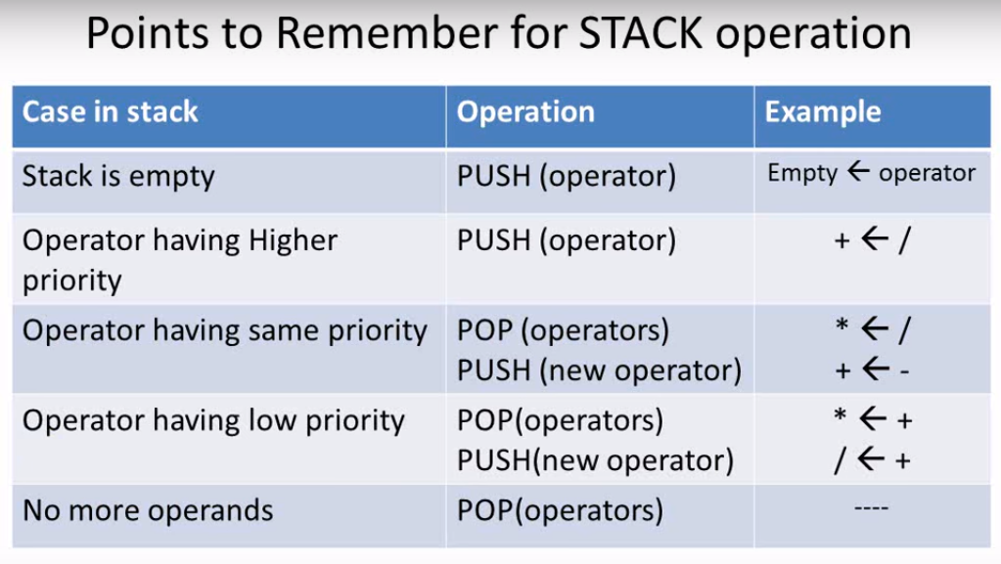

Note:
Ignore rules when brackets is in the top of the stack.
POP All the elements from Opening to closing Brackets when we inserted closing bracket into the stack.

Infix to Prefix
In this ,First we Reverse the Infix Expression then apply Similar Rules using Stack. And also reverse Final Result for making it into prefix.
Note: Rule is Similar as We applied in the Conversion Of Infix to Post Fix
Or
Same Rules as we applied on Infix to Post Coversion But for Infix to Prefix , Scanning Infix Expression should be from right to left.

